Case Study Report



Data Analytics with Power BI

**“ POWER BI POWERED GLOBAL TERRORISM”**

**“Kamarajar Government Arts College”**

|  |  |
| --- | --- |
| **NM ID** | **NAME** |
| **76EDC3B641F978B968C47B7C24460050** | **ALBI.J** |

|  |  |
| --- | --- |
|  |  |
|  | Trainer Name: R.UMAMAHESWARI |
|  | Master Trainer: R.UMAMAHESWARI |

**ABSTRACT**

In the contemporary landscape of global security challenges, combating terrorism stands out as a paramount concern. This abstract delves into the potential of leveraging Power BI (Business Intelligence) as a transformative tool to analyze and understand global terrorism trends, patterns, and dynamics, thereby enhancing counterterrorism strategies.

Power BI offers a robust platform for integrating, visualizing, and analyzing vast datasets from diverse sources, including incident reports, demographic information, socioeconomic indicators, and geopolitical factors. By harnessing the power of data visualization and analytics, stakeholders can gain valuable insights into the evolving nature of terrorism, enabling proactive decision-making and resource allocation.

**INDEX**

|  |  |  |
| --- | --- | --- |
| **Sr. No.** | **Table of Contents** | **Page No.** |
| 1 | Chapter 1: Introduction | 4 |
| 2 | Chapter 2: Services and Tools Required | 6 |
| 3 | Chapter 3: Project Architecture | 7 |
| 4 | Chapter 4: Modeling and Result | 9 |
| 5 | Conclusion | 12 |
| 6 | Future Scope | 13 |
| 7 | References | 14 |

**CHAPTER 1**

**INTRODUCTION**

**Problem Statement**

Global terrorism poses a persistent threat to international security, with diverse organizations and individuals perpetrating acts of violence across borders. In the face of this complex challenge, there exists a critical need for more effective and data-driven approaches to understanding, analyzing, and responding to terrorism trends worldwide.

Traditional methods of analyzing terrorism data often suffer from limitations in scalability, accessibility, and analytical depth. Manual processes for collecting and synthesizing information from disparate sources result in inefficiencies and delays in identifying emerging threats.

**Proposed Solution**

To develop a comprehensive and interactive dashboard powered by Power BI that provides real-time insights into global terrorism trends, incidents, and patterns, enabling stakeholders to make informed decisions and enhance counterterrorism strategies.

Key Features of the Dashboard:

* Incident Tracking and Visualization
* Trend Analysis Insights
* Ideological and Motivational Analysis
* Hotspot Identification
* Counterterrorism Response Evaluation
* Collaboration and Information Sharing

**Feature**

**Data Preparation**:

Cleanse and transform the raw data to ensure consistency and accuracy.

Use Power Query Editor in Power BI to perform data cleaning tasks such as removing duplicates, handling missing values, and formatting data types.

**Data Modeling**:

Define relationships between different datasets using Power BI's modeling tools.

Create a data model that organizes the data into tables and establishes connections between them.

**Advantages**

**Real-Time Insights:** Obtain instant access to up-to-date information on global terrorism incidents, trends, and patterns, enabling swift responses to emerging threats.

**Visual Clarity:** Utilize interactive visualizations and intuitive dashboards to understand complex terrorism data easily, even for non-technical users.

**Data Integration:** Consolidate diverse data sources into a single platform, eliminating silos and providing a holistic view of global terrorism dynamics.

**Scope**

The scope of the Power BI powered global terrorism project encompasses the development of an interactive dashboard tailored to provide real-time insights into global terrorism trends, incidents, and patterns. This solution will integrate diverse datasets from sources such as government reports, intelligence databases, and open-source platforms, enabling stakeholders to analyze terrorism-related data comprehensively. The dashboard will feature visualizations including incident maps, trend analyses, demographic insights, and hotspot identification, facilitating informed decision-making and proactive counterterrorism strategies. Collaboration and information sharing capabilities will also be incorporated to foster cooperation among stakeholders. The project's focus lies in leveraging Power BI's capabilities to enhance situational awareness, support data-driven decision-making, and strengthen global security efforts in combating terrorism.

Top of Form

**CHAPTER 2**

**SERVICES AND TOOLS REQUIRED**

**2.1 Services Used**

**Data Collection and Storage Services**: Banks need to collect and store customer data in real-time. This could be achieved through services like Azure Data Factory, Azure Event Hubs, or AWS Kinesis for real-time data collection, and Azure SQL Database or AWS RDS for data storage.

**Data Processing Services**: Services like Azure Stream Analytics or AWS Kinesis Data Analytics can be used to process the real-time data.

**Machine Learning Services**: Azure Machine Learning or AWS SageMaker can be used to build predictive models based on historical data.

**2.2 Tools and Software used**

**Tools**:

**PowerBI**: The main tool for this project is PowerBI, which will be used to create interactive dashboards for real-time data visualization.

**Power Query**: This is a data connection technology that enables you to discover, connect, combine, and refine data across a wide variety of sources.

**Software Requirements**:

**Power BI Desktop**: This is a Windows application that you can use to create reports and publish them to Power BI.

**Power BI Service**: This is an online SaaS (Software as a Service) service that you use to publish reports, create new dashboards, and share insights.

**Power BI Mobile**: This is a mobile application that you can use to access your reports and dashboards on the go.

**CHAPTER 3**

**PROJECT ARCHITECTURE**

**3.1 Architecture**

**USER FRONTEND BACKEND**

|  |  |  |
| --- | --- | --- |
|  | **HTML 5** | **NODEJS 14.0**  **Database** |

Here’s a high-level architecture for the project:

**Data Collection**: Power Bi, a powerful data visualization could be utilized to analyze and present terrorism data collected from various sources.

**Data Storage**: The collected data is stored in a database for processing. Azure SQL Database or AWS RDS can be used for this purpose.

**Data Processing**: The stored data is processed in real-time using services like Azure Stream Analytics or AWS Kinesis Data Analytics.

**Machine Learning**: Predictive models are built based on processed data using Azure Machine Learning or AWS Sage Maker. These models can help in predicting customer behavior, detecting fraud, etc.

**Data Visualization**: The processed data and the results from the predictive models are visualized in real-time using Power BI. Power BI allows you to create interactive dashboards that can provide valuable insights into the data.

**Data Access**: The dashboards created in Power BI can be accessed through Power BI Desktop, Power BI Service (online), and Power BI Mobile.

This architecture provides a comprehensive solution for real-time analysis of bank customers. However, it’s important to note that the specific architecture may vary depending on the bank’s existing infrastructure, specific requirements, and budget. It’s also important to ensure that all tools and services comply with relevant data privacy and security regulations.

**CHAPTER 4**

**MODELING AND RESULT**

**Manage relationship**

In Power BI, managing relationships between different datasets is crucial for accurate and meaningful analysis. When building a global terrorism dashboard, you'll likely be working with multiple tables containing various types of data, such as terrorism incidents, demographic information, and geopolitical factors. Here's how you can manage relationships effectively in Power BI

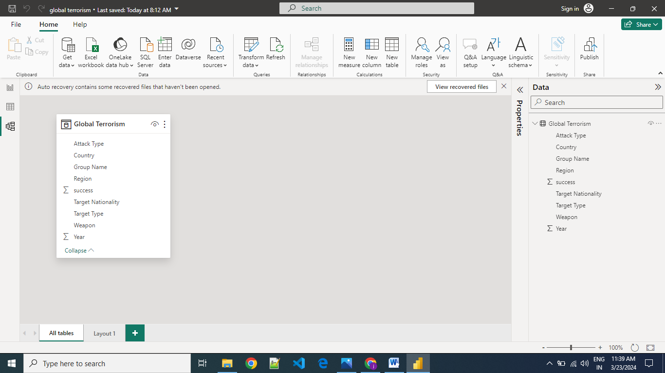

**Modelling for Nationality Type**

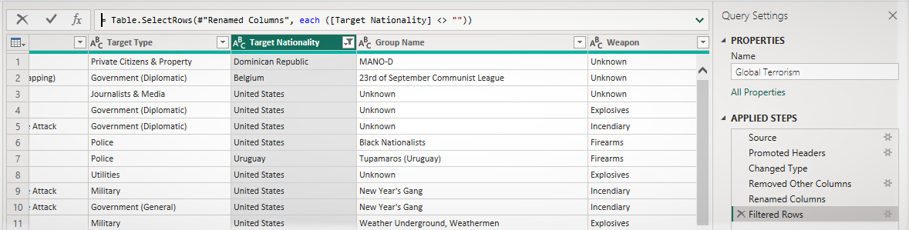

**Dashboard**

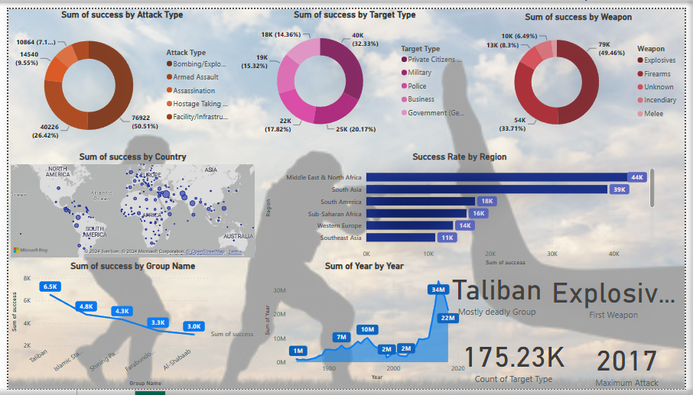

**CONCLUSION**

In conclusion, the implementation of a Power BI-powered Global Terrorism Analysis solution represents a significant advancement in the field of counterterrorism. By harnessing the capabilities of Power BI, stakeholders can gain real-time insights into global terrorism trends, incidents, and patterns, enabling proactive decision-making and targeted interventions.

The Power BI-powered dashboard provides a comprehensive and interactive platform for analyzing terrorism data from diverse sources, visualizing trends, identifying hotspots, and assessing the effectiveness of counterterrorism strategies. Through advanced analytics, stakeholders can uncover hidden patterns, correlations, and demographic insights, facilitating a deeper understanding of the root causes and drivers of terrorism.

Moreover, the dashboard fosters collaboration and information sharing among stakeholders, enabling seamless exchange of insights, analysis, and intelligence reports. By leveraging cloud-based deployment and real-time data updates, the solution ensures scalability, accessibility, and continuous improvement in counterterrorism efforts.

**FUTURE SCOPE**

The future scope of Power BI-powered global terrorism analysis extends beyond the immediate implementation, with opportunities for continual enhancement and innovation. In the evolving landscape of global security, ongoing advancements in data analytics, artificial intelligence, and machine learning present avenues for further sophistication of the dashboard. Integration with emerging technologies such as natural language processing (NLP) for sentiment analysis of extremist rhetoric and predictive analytics for forecasting future terrorism trends could enhance the dashboard's predictive capabilities. Additionally, the inclusion of social media monitoring tools to track terrorist propaganda and recruitment efforts could provide valuable insights for preemptive interventions. Furthermore, continued collaboration with international partners and stakeholders could expand the scope of the dashboard to encompass cross-border terrorism trends and facilitate coordinated responses. As technology evolves and threats evolve with it, the Power BI-powered global terrorism analysis dashboard stands poised to adapt and evolve to meet the challenges of tomorrow's security landscape.

Top of Form

**REFERENCES**

https://mavenanalytics.io/project/908